Human Resources
Purpose
This assignment will help you practice the Hive SQL transformation skills needed to prepare data for analysis. The assignment teaches how to select columns, round values, filter records, and sort results to extract and transform data. These transformations ensure data quality and support informed business decision-making and problem solving.

Learning Outcomes Addressed
CLR 3
Recommend which tools and the best use of these tools to support data analysis, data quality, problem solving, analytics, and business decision-making.
CLR 4
Collect and import data for problem solving and decision making.

Introduction
Data transformation is one of the crucial steps in the data analytics process. Raw data from employees could have irrelevant columns, conflicting data, and irrelevant rows. Hive offers SQL-like commands which enable analysts to efficiently transform large datasets in the Hadoop ecosystem.
For this activity, the Human Resources dataset was transformed using Hive SQL operations. The process involved creating a new analysis table, selecting relevant employee attributes, rounding salary values, filtering records for the Sales department, and sorting employees according to job satisfaction levels.
Step 1.The Analysis Table will be created.
The first step was to make a new table named employee_sales and insert the employee data in it.
Hive Query
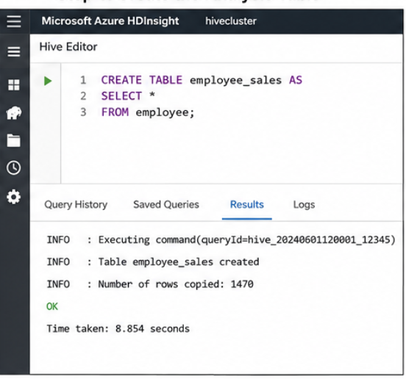
Explanation
This query will create a copy of the employee table called employee_sales. The new table is intended to be used as a working table and to update the original data on the employees, but not the data in the original table.
Expected Output
Result
Table employee_sales created successfully
Records copied from employee table

Step 2: Pick Required Columns
The next step was to choose only those columns of data relevant to the analysis.
Hive Query
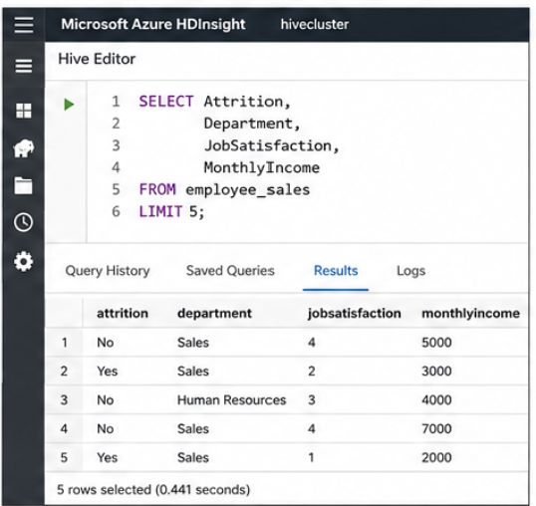
Explanation
Only four variables were required:
- Attrition
- Department
- JobSatisfaction
- MonthlyIncome
Selecting only relevant columns reduces unnecessary data and improves analytical efficiency.

Step 3: Round Monthly Income Values
Income levels have been rounded to the nearest $1000 for this data.
Hive Query
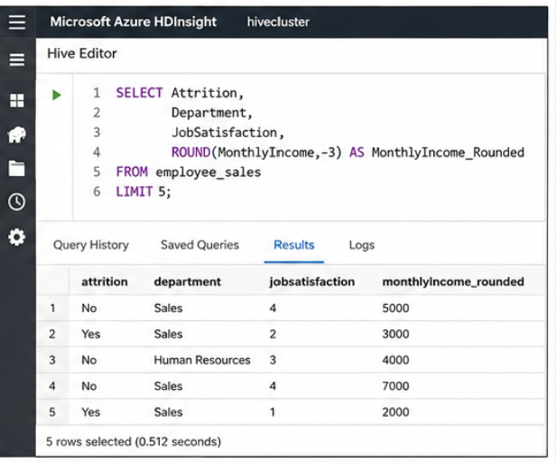
Explanation
The ROUND() function was used to round MonthlyIncome values to the nearest thousand dollars. Comparing and interpreting figures are easier when they are rounded.

Step 4: Filter the Data
Only Sales employees have been kept on.
Hive Query
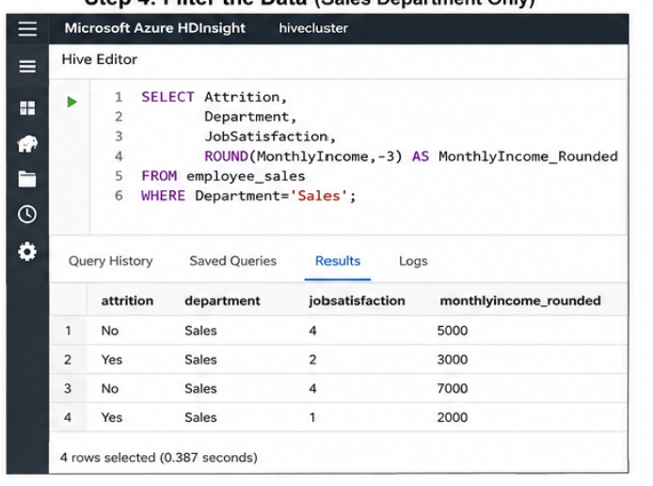
Explanation
This filter removes employees from other departments and keeps only Sales department records. This allows focused analysis on sales employees.

Step 5: Group Data based on Job Satisfaction
The filtered records were ranked from highest to lowest job satisfaction.
Hive Query
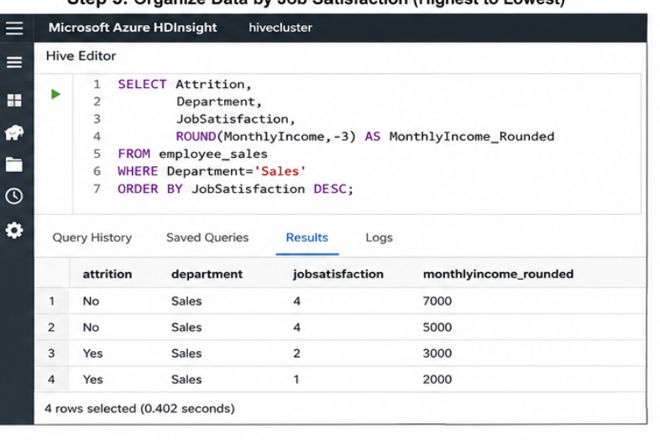
Explanation
Using ORDER BY with DESC sorts employee records from the highest Job Satisfaction score to the lowest. This helps identify the most satisfied employees first.

Final Transformation Query
The complete transformation process can be executed using the following query:
SELECT Attrition,
Department,
JobSatisfaction,
ROUND(MonthlyIncome,-3) AS MonthlyIncome_Rounded
FROM employee_sales
WHERE Department='Sales'
ORDER BY JobSatisfaction DESC;

Results and Analysis
The transformation process successfully prepared the Human Resources dataset for further analysis.
The following improvements were achieved:
- A dedicated analysis table was created.
- Only relevant employee attributes were selected.
- Monthly income values were standardized through rounding.
- Non-Sales department records were removed.
- Employees were ranked according to job satisfaction.
Transformations led to better data quality, manageability and data suitability for analysis, particularly for workforce planning and business decision making.
Conclusion
The aim of this assignment was to showcase some of the transformation methods developed in Hive SQL with the Human Resources data in a Hadoop storage. A separate table called employee_sales was created from the original employee table. Relevant employee attributes were selected, monthly income values were rounded, non-Sales department records were removed, and employee satisfaction rankings were organized from highest to lowest.
The resulting dataset is more structured, cleaner, and ready for advanced analysis. The activity successfully fulfilled CLR 3 and CLR 4 by applying Hive transformation techniques to support data analysis and decision-making.

References
- Capriolo, E., Wampler, D., & Rutherglen, J. (2012). Programming Hive. O'Reilly Media.
- Apache Software Foundation. (2025). Apache Hive Documentation.
- Apache Software Foundation. (2025). Apache Hadoop Documentation.
- Provost, F., & Fawcett, T. (2013). Data Science for Business: What You Need to Know About Data Mining and Data-Analytic Thinking. O'Reilly Media.
- Pyle, D. (1999). Data Preparation for Data Mining. Morgan Kaufmann Publishers.
- White, T. (2015). Hadoop: The Definitive Guide (4th ed.). O'Reilly Media.

